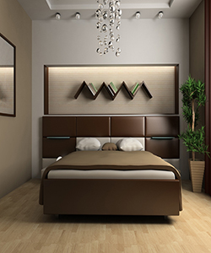

### Most stylish and comfortable Durian Bed

$392.15

Availability: In stock

### Description

Easy does it. Solid rubber wood frame and a classic headboard are well matched in this walnut finish bed. Perfect for a bedroom that’s classic and functional, this is the ideal starter piece for your home. Bedroom Collection that will look stunning in your newly built or renovated home. Durian bringing the best of products of Beds at the best prices! Mattress and other accessories not included, unless specified otherwise